LABORATORIYA ISHI №10

Mavzu: Bootstrap yordamida adaptiv sahifa yaratish

Ishdan maqsad
Talabalarda Bootstrap frameworkidan foydalanib, turli qurilmalarga moslashuvchi (responsive) veb sahifa yaratish ko‘nikmalarini shakllantirish.
Nazariy qism
Bootstrap nima?
Bootstrap — bu HTML, CSS va JavaScript asosida yaratilgan ochiq kodli frontend framework bo‘lib, tez va qulay tarzda zamonaviy veb sahifalar yaratishga yordam beradi.

Adaptiv dizayn (Responsive design)
Adaptiv dizayn — bu veb sahifaning:
- telefon 📱
- planshet 📱
- kompyuter 💻
kabi turli ekran o‘lchamlariga moslashishidir.

Bootstrap grid tizimi
Bootstrap 12 ustundan iborat grid tizimdan foydalanadi:
- .col- — kichik ekranlar
- .col-sm-
- .col-md-
- .col-lg-
- .col-xl-

Bootstrap grid misollari
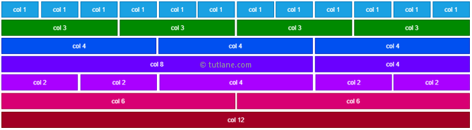
Kerakli vositalar
- Matn muharriri (VS Code yoki boshqa)
- Brauzer (Chrome, Firefox)
- Internet (Bootstrap CDN uchun)

Amaliy misollar

1-Misol: Bootstrap ulash
Quyidagi kod orqali Bootstrap CDN ni ulang:
<!DOCTYPE html>
<html lang="uz">
<head>
<meta charset="UTF-8">
<meta name="viewport" content="width=device-width, initial-scale=1.0">
<title>Bootstrap sahifa</title>
<link href="https://cdn.jsdelivr.net/npm/bootstrap@5.3.0/dist/css/bootstrap.min.css" rel="stylesheet">
</head>
<body>
</body>
</html>

2-misol: Navbar yaratish
<nav class="navbar navbar-expand-lg navbar-dark bg-dark">
<div class="container">
<a class="navbar-brand" href="#">Mening sayt</a>
</div>
</nav>
3-misol: Grid tizimdan foydalanish
<div class="container mt-4">
<div class="row">
<div class="col-md-4 bg-primary text-white p-3">1-blok</div>
<div class="col-md-4 bg-success text-white p-3">2-blok</div>
<div class="col-md-4 bg-danger text-white p-3">3-blok</div>
</div>
</div>

4-misol: Kartalar (Cards) qo‘shish
<div class="container mt-4">
<div class="row">
<div class="col-md-4">
<div class="card">
<div class="card-body">
<h5 class="card-title">Sarlavha</h5>
<p class="card-text">Matn joylashadi</p>
</div>
</div>
</div>
</div>
</div>

5-topshiriq: Adaptivlikni tekshirish
- Brauzerni kichraytirib ko‘ring
- Developer tools (F12) orqali turli qurilmalarda sinab ko‘ring
Topshiriq

7. Rasm galereyasi
Rasmlardan iborat galereya yarating:
- mobil: 1 ustun
- planshet: 2 ustun
- kompyuter: 4 ustun
Kod
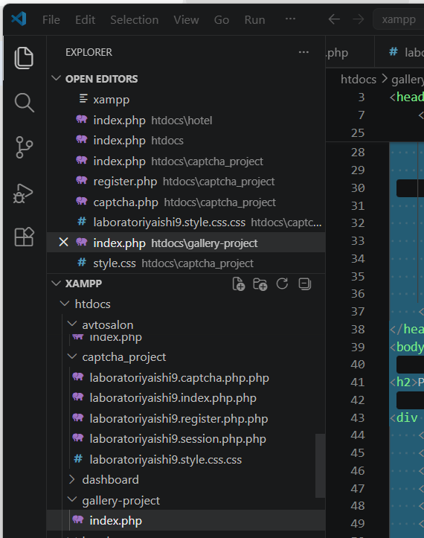
•kompyuter: 4 ustun
<!DOCTYPE html>
<html lang="uz">
<head>
<meta charset="UTF-8">
<meta name="viewport" content="width=device-width, initial-scale=1.0">
<title>Rasm Galereyasi</title>

<style>
body {
margin: 0;
font-family: Arial, sans-serif;
}

h2 {
text-align: center;
margin: 20px 0;
}

.gallery {
display: grid;
gap: 10px;
padding: 10px;
}

.gallery img {
width: 100%;
height: auto;
border-radius: 10px;
}

/* 📱 Mobil */
.gallery {
grid-template-columns: 1fr;
}

/* 📲 Planshet */
@media (min-width: 600px) {
.gallery {
grid-template-columns: repeat(2, 1fr);
}
}

/* 💻 Kompyuter */
@media (min-width: 992px) {
.gallery {
grid-template-columns: repeat(4, 1fr);
}
}
</style>
</head>
<body>

<h2>Rasm Galereyasi</h2>

<div class="gallery">
<?php
for ($i = 1; $i <= 8; $i++) {
echo "<img src='https://picsum.photos/300?random=$i' alt='Rasm'>";
}
?>
</div>

</body>
</html>
Natija
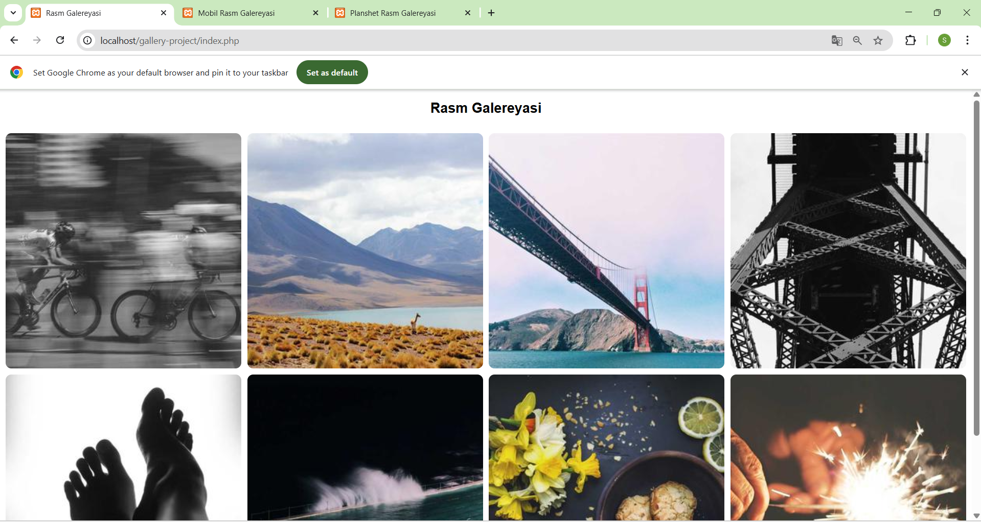
Mobil → 1 ustun
<!DOCTYPE html>
<html lang="uz">
<head>
<meta charset="UTF-8">
<meta name="viewport" content="width=device-width, initial-scale=1.0">
<title>Mobil Rasm Galereyasi</title>
<style>
body {
margin: 0;
font-family: Arial, sans-serif;
}

h2 {
text-align: center;
margin: 20px 0;
}

.gallery {
display: grid;
gap: 10px;
padding: 10px;
grid-template-columns: 1fr; /* ✅ Mobil: 1 ustun */
}

.gallery img {
width: 100%;
height: auto;
border-radius: 10px;
}
</style>
</head>
<body>

<h2>Mobil Rasm Galereyasi (1 ustun)</h2>

<div class="gallery">
<?php
// 8 ta rasm misol uchun
for ($i = 1; $i <= 8; $i++) {
echo "<img src='https://picsum.photos/300?random=$i' alt='Rasm'>";
}
?>
</div>

</body>
</html>

Natija
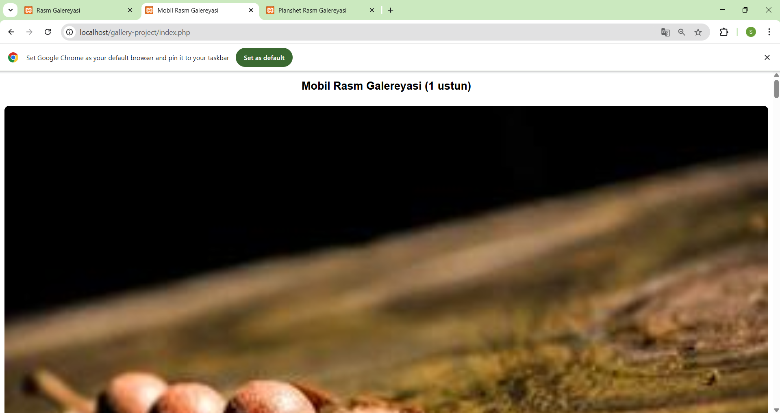
index.html (Planshet → 2 ustun)
<!DOCTYPE html>
<html lang="uz">
<head>
<meta charset="UTF-8">
<meta name="viewport" content="width=device-width, initial-scale=1.0">
<title>Planshet Rasm Galereyasi</title>
<style>
body {
margin: 0;
font-family: Arial, sans-serif;
}

h2 {
text-align: center;
margin: 20px 0;
}

.gallery {
display: grid;
gap: 10px;
padding: 10px;
grid-template-columns: 1fr; /* Default: 1 ustun (mobil) */
}

.gallery img {
width: 100%;
height: auto;
border-radius: 10px;
}

/* Planshet: 2 ustun */
@media (min-width: 600px) {
.gallery {
grid-template-columns: repeat(2, 1fr);
}
}
</style>
</head>
<body>

<h2>Planshet Rasm Galereyasi (2 ustun)</h2>

<div class="gallery">
<img src="https://picsum.photos/300?random=1" alt="Rasm 1">
<img src="https://picsum.photos/300?random=2" alt="Rasm 2">
<img src="https://picsum.photos/300?random=3" alt="Rasm 3">
<img src="https://picsum.photos/300?random=4" alt="Rasm 4">
<img src="https://picsum.photos/300?random=5" alt="Rasm 5">
<img src="https://picsum.photos/300?random=6" alt="Rasm 6">
<img src="https://picsum.photos/300?random=7" alt="Rasm 7">
<img src="https://picsum.photos/300?random=8" alt="Rasm 8">
</div>

</body>
</html>

Natija
